System and Software Architecture Description (SSAD)

Yanomamo Interactive CDROM

Team [06]

System Architect - Shruti Sannabhadti

Project Manager - Reetika Rastogi

Requirements Engineer - Rohit Mani

Feasibility Analyst - Sanjay Kutty

Operational Concept Engineer - Tushar Saxena

Prototyper - Cristina Cano

Image20.png

USC-CSSE

# Version History

| Date | Author | Version | Changes made | Rationale |
| --- | --- | --- | --- | --- |
| 13/16/10 | Shruti | 1.0 | * Auto-generated from VP-UML | * Initial SSAD for FC Package |
| 13/23/10 | Shruti | 2.0 | * Added Sequence, Hardware, Software Component, Deployment, Requirement Diagrams and Requirements & Use-Case Grids. | * SSAD for DC Package |
| 13/1/12 | Shruti | 3.0 | * Added Artifacts and Information Diagram, made changes to Deployment, Hardware, & Software Component Diagrams according to new Client Requirement, and added NDI/NCS interoperability section. | * SSAD for draft TRR Package |

Table of Contents

Introduction…………………………………………………………………………………………………………...4

System Context Diagram 5

Requirement Diagram 6

Requirements Grid 7

Artifacts & Information Diagram 8

Behavior 9

Use-Case Descriptions…………………………………………………………………………………………….10

Use Cases Grid 17

Design Class Diagram 18

Link Text to TBM Sequence Diagram 19

Link Text to Genealogy Statistics, and Highlight on TBM Sequence Diagaram 20

Hardware Component Diagram 21

Software Component Diagram 22

Deployment Diagram 23

NDI/NCS Interoperability Analysis…………………………………………………………………………………...

Table of Figures

System Context Diagram

Requirement Diagram

Artifacts & Information Diagram

Behavior

Design Class Diagram

Link Text to TBM Sequence Diagram

Link Text to Genealogy Statistics, and Highlight on TBM Sequence Diagaram

Hardware Component Diagram

Software Component Diagram

Deployment Diagram

**Introduction**

#### Purpose of the SSAD

The purpose of this document is to analyze and design the architecture of the Yanomamo Interactive web page system and also evaluate the interoperability of the various COTS used as a part of development of the system.

#### Status of the SSAD

The version no. of this SSAD is 3.0 and it is different from the previous version, due to certain changes such as: **addition of Artifacts and Information Diagram after evaluation of DC Package and changes in Deployment, Hardware, & Software Component Diagrams, according to increase in priority of Client Requirement of deployment on DVD, and addition of NDI/NCS interoperability section**.

# System Context Diagram

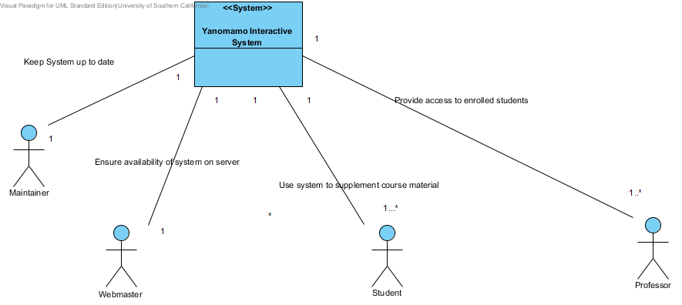

# 

# Requirement Diagram

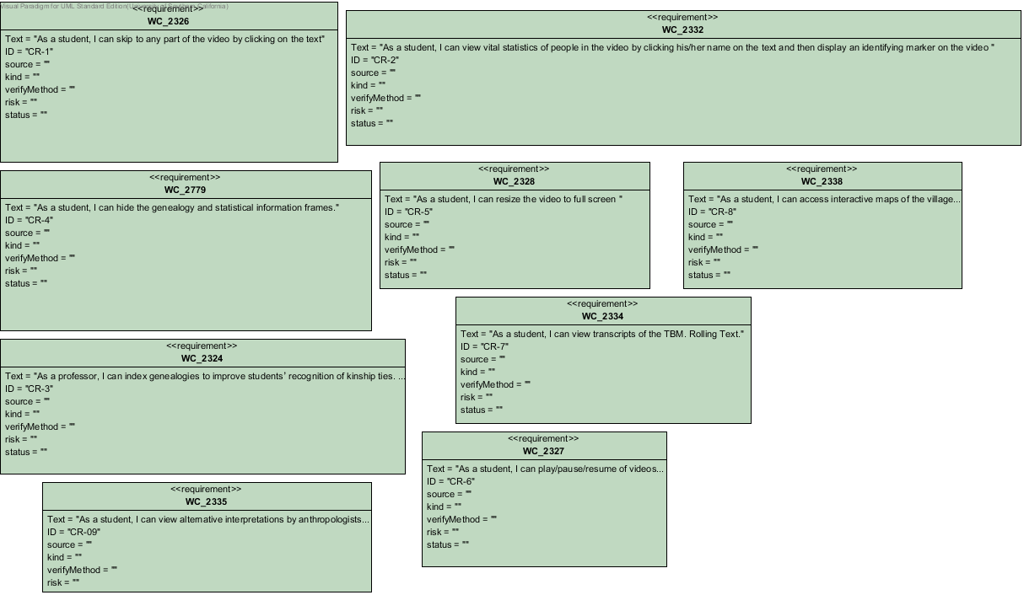

# Requirements Grid

|  |  |  |
| --- | --- | --- |
| ID | Name | Documentation |
| CR-1 | WC_2326 | As a student, I can skip to any part of the video by clicking on the text |
| CR-2 | WC_2332 | As a student, I can view vital statistics of people in the video by clicking his/her name on the text and then display an identifying marker on the video |
| CR-3 | WC_2324 | As a professor, I can index genealogies to improve students’ recognition of kinship ties. Link to names |
| CR-4 | WC_2779 | As a student, I can hide the genealogy and statistical information frames. |
| CR-5 | WC_2328 | As a student, I can resize the video to full screen |
| CR-6 | WC_2327 | As a student, I can play/pause/resume of videos to improve the learning environment. Optionally, I can control the speed of the video |
| CR-7 | WC_2334 | As a student, I can view transcripts of the TBM. Rolling Text. |
| CR-8 | WC_2338 | As a student, I can access interactive maps of the village in the video so that I know where people are in relation to others and geographically in relation to the rest of the world |
| CR-09 | WC_2335 | As a student, I can view alternative interpretations by anthropologists (Chagnon) of the TBM/texts/literature/research papers |

# Artifacts & Information Diagram

The artifacts & information, in this system are the various kinds of text files like transcripts, statistics, etc. and video, and image files. Each of these data files, have certain properties associated with them such as name, subject, links, etc. and hence, can be considered as artifacts. They are linked to each other with hyperlinks.

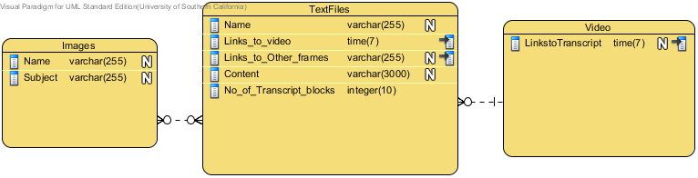

# Behaviour

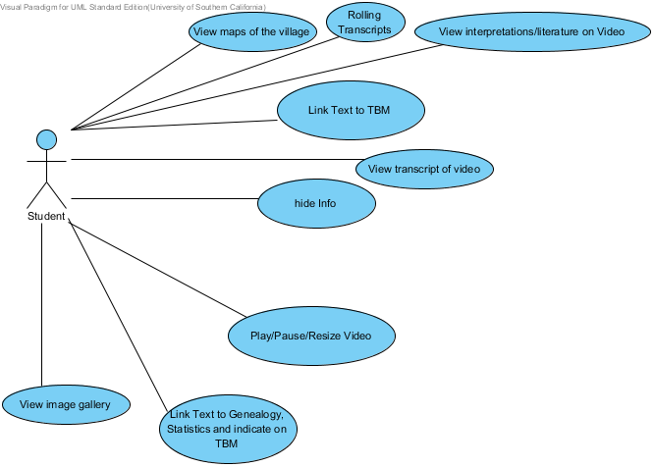

### Use-Case Descriptions

### Image9.png Link Text to TBM

#### Use Case Descriptions

|  |  |
| --- | --- |
| Main | |
| **Use Case** | UC01:Link Text to TBM |
| **Requirements** | WC_2326: As a student, I can skip to any part of the video by clicking on the text |
| **Purpose** | To allow students to easily view, understand and analyze the events described in the text by loading the specific portion of the video, that the text is referring to. |
| **Preconditions** | Video and Transcripts are loaded in the homepage. |
| **Post-conditions** | Student can view portion of video, referred to by text. |
| **Flow of Events** | |  |  |  | | --- | --- | --- | |  | Actor Input | System Response | | 1 | Student clicks on any word in any paragraph in the transcript |  | | 2 |  | Jump to specific time frame in video. | |

### Image9.png Link Text to Genealogy, Statistics and indicate on TBM

#### Use Case Descriptions

|  |  |
| --- | --- |
| Main | |
| **Use Case** | UC02:Link Text to Genealogy, Statistics and indicate on TBM |
| **Requirement** | WC_2332 As a student, I can view vital statistics of people in the video by clicking his/her name on the text and then display an identifying marker on the video  WC_2324 As a professor, I can index genealogies to improve students’ recognition of kinship ties. Link to names |
| **Purpose** | To allow students to understand relationships between tribe members, recognize key individuals in the video, and their demographic information. |
| **Preconditions** | Homepage, video and interactive transcript load |
| **Post-conditions** | Genealogy, statistics frames displayed and tribe member highlighted in video. Hide info button option is made available. |
| **Flow of Events** | |  |  |  | | --- | --- | --- | |  | Actor Input | System Response | | 1 | Student clicks on tribe member name in the transcript. |  | | 2 |  | Display Genealogy, Statistics frames for that tribe member, and display a circle identifying him/her in the video. | |

|  |  |
| --- | --- |
| Exceptional Course of Action | |
| **Flow of Events** | |  |  |  | | --- | --- | --- | |  | Actor Input | System Response | | 1 | Student clicks on tribe member name in the transcript. |  | | 2 |  | In case, the files or images for genealogy, statistics, do not load, display error message. | |

### Image9.png hide Info

#### Use Case Descriptions

|  |  |
| --- | --- |
| Main | |
| **Use Case** | UC03: Hide Info |
| **Requirements** | WC_2779 : As a student, I can hide the genealogy and statistical information frames. |
| **Purpose** | To provide an option to the student to hide the genealogy and statistical information, if he/she wants to concentrate only on the video and the transcripts, at the moment. |
| **Preconditions** | The genealogy and statisctical frames are displayed on the home page. |
| **Post-conditions** | Genealogy and statistical information is hidden from the student. |
| **Flow of Events** | |  |  |  | | --- | --- | --- | |  | Actor Input | System Response | | 1 | Student clicks on hide info button. |  | | 2 |  | Hides the genealogy and statistics frames. | |

### Image9.png Play/Pause/Resize Video

#### Use Case Descriptions

|  |  |
| --- | --- |
| Main | |
| **Use Case** | UC04: Play/Pause/Resize Video |
| **Requirement** | WC_2328 As a student, I can resize the video to full screen  WC_2327 As a student, I can play/pause/resume of videos to improve the learning environment. Optionally, I can control the speed of the video |
| **Purpose** | To allow students to control the video as they are watching it, according to their needs. |
| **Preconditions** | Homepage and video loads |
| **Post-conditions** | Video is either playing or paused, or resized to full screen. |
| **Flow of Events** | |  |  |  | | --- | --- | --- | |  | Actor Input | System Response | | 1 | Student clicks on play, or pause, or resize buttons of video player. |  | | 2 |  | Video is played, or is paused, or is made to run in full screen mode. | |

### Image9.png View transcript of video

#### Use Case Descriptions

|  |  |
| --- | --- |
| Main | |
| **Use Case** | UC05: View transcript of video |
| **Requirement** | WC_2334 As a student, I can view transcripts of the TBM. |
| **Purpose** | To widen student's understanding of events in the video |
| **Preconditions** | Homepage and Video loads |
| **Post-conditions** | Trancript loads |
| **Flow of Events** | |  |  |  | | --- | --- | --- | |  | Actor Input | System Response | | 1 | Student opens Yanomamo Home page |  | | 2 |  | Transcript for Video loads | |

### Image9.png View interpretations/literature on Video

#### Use Case Descriptions

|  |  |
| --- | --- |
| Main | |
| **Use Case** | UC06: View interpretations/literature on video |
| **Requirements** | WC_2335 As a student, I can view alternative interpretations by anthropologists (Chagnon) of the TBM/texts/literature/research papers |
| **Purpose** | To widen students' understanding of the context of events by reading different analyses, and interpretations. |
| **Preconditions** | Homepage, video, transcript loads. |
| **Post-conditions** | Interpretations/ Literature page loads. |
| **Flow of Events** | |  |  |  | | --- | --- | --- | |  | Actor Input | System Response | | 1 | Student clicks on the Interpretations/Literature link in home page |  | | 2 |  | Displays the interpretations /Literature page. | |

### Image9.png View maps of the village

#### Use Case Descriptions

|  |  |
| --- | --- |
| Main | |
| **Use Case** | UC07 : View Maps of the village |
| **Requirements** | WC_2338 As a student, I can access interactive maps of the village in the video so that I know where people are in relation to others and geographically in relation to the rest of the world |
| **Purpose** | To allow students to gain perspective from the geography/location of the Yanomamo tribe. |
| **Preconditions** | Homepage loads. |
| **Post-conditions** | Static Map of the tribal village loads. |
| **Flow of Events** | |  |  |  | | --- | --- | --- | |  | Actor Input | System Response | | 1 | Student clicks on the link for the map of the village |  | | 2 |  | Display static map of the tribe's village | |

### Image9.png View image gallery

#### Use Case Descriptions

|  |  |
| --- | --- |
| Main | |
| **Use Case** | UC08: View image gallery |
| **Requirements** | WC_2331 As a student, I can view just the image gallery of stills (people, maps, chart, tables) |
| **Purpose** | To allow students to understand the tribe better with additional information in the form of images and to provide separate and easy access to only the stills. |
| **Preconditions** | Homepage loads |
| **Post-conditions** | The page containing the image gallery loads. |
| **Flow of Events** | |  |  |  | | --- | --- | --- | |  | Actor Input | System Response | | 1 | Student clicks on the image gallery link on the home page |  | | 2 |  | Display image gallery page. | |

### Image9.png Rolling Transcripts

#### Use Case Descriptions

|  |  |
| --- | --- |
| Main | |
| **Use Case** | UC09: Rolling Transcripts |
| **Requirements** | WC_2334: As a student, I can view transcripts of the TBM. Rolling Text. |
| **Purpose** | The student can click on any point in the video, and be able to see the corresponding transcript block, narrating that portion of video, so as to make the application more user friendly. |
| **Preconditions** | Video frame of homepage has loaded and video is playing. |
| **Post-conditions** | Corresponding transcript block displayed in interactive transcript frame of home page. |
| **Flow of Events** | |  |  |  | | --- | --- | --- | |  | Actor Input | System Response | | 1 | Student clicks on a point in the video on the control bar. |  | | 2 |  | Display transcript block corresponding to that time of video, in transcript frame of home page. | |

# Use Cases Grid

|  |  |  |  |
| --- | --- | --- | --- |
| ID | Name | Primary Actors | Supporting Actors |
| UC01 | Link Text to TBM | Student |  |
| UC02 | Link Text to Genealogy, Statistics and indicate on TBM | Student |  |
| UC03 | hide Info | Student |  |
| UC04 | Play/Pause/Resize Video | Student |  |
| UC05 | View transcript of video | Student |  |
| UC06 | View interpretations/literature on Video | Student |  |
| UC07 | View maps of the village | Student |  |
| UC08 | View image gallery | Student |  |
| UC09 | Rolling Transcripts | Student |  |

# Design Class Diagram

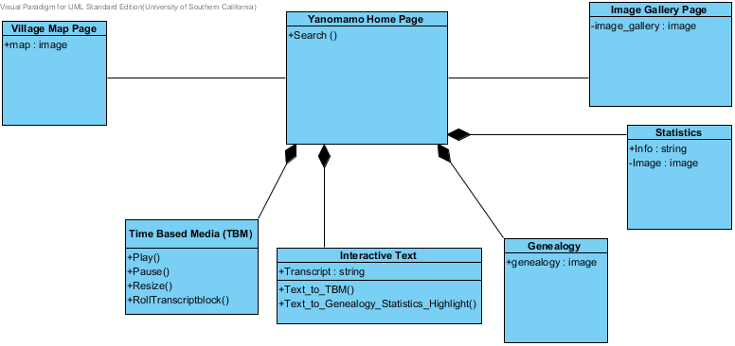

# Link Text to TBM Sequence Diagram

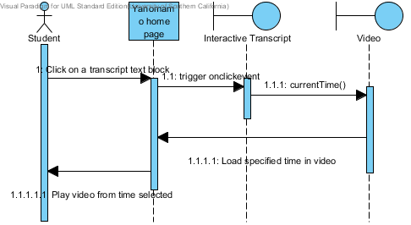

# 

# Link Text to Genealogy Statistics, and Highlight on TBM Sequence Diagram

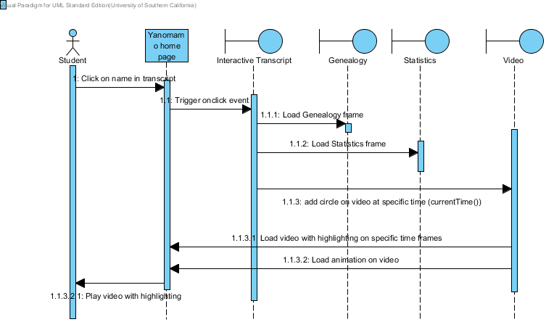

# Hardware Component Diagram

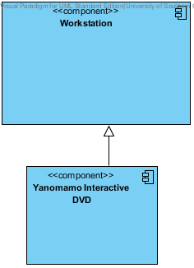

# Software Component Diagram

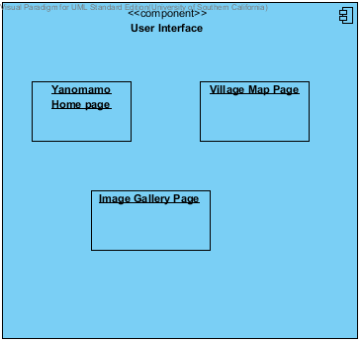

# Deployment Diagram

### Image18.png

### NDI/NCS Interoperability Analysis

#### Introduction

The libraries we are using, are needed for separate, independent features and hence, do not interact with each other.

##### COTS / GOTS / ROTS / Open Source / NCS

<< Identify all candidate commercial off-the-shelf, government-off-the-shelf, research-off-the-shelf, open source software, libraries, and net-centric services component that you are using/ plan to use. Also identify the purpose of each component. >>

Table 7: NDI Products Listing

|  |  |
| --- | --- |
| **NDI/NCS Products (COTS)** | **Purposes** |
| Popcorn.js | Link text to video and video to text, to jump to a specific portion of video on clicking the text or jump to specific transcript block on clicking on a specific time point on the control bar in video. |
| Kinetic.js | Link text to specific individual in video i.e. (video overlay animation) |
| Kinetic-viewport.js | Zooming and Panning of images and maps. |
| menucool js-image-slider | Image gallery functionality |

##### **Connectors**

##### There are no connectors, since there is no interaction between the COTS used.

##### **Legacy System**

#### The client uses an apple workstation, and hence the libraries used, have to be compatible with Safari browser.

#### System Structure

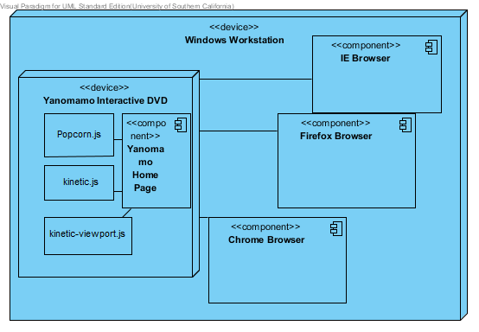

#### 

#### The system structure is similar for a mac osx workstation with the exception an in-built safari browser,

#### instead of an IE browser.

#### Evaluation Summary

Table : NDI Evaluation

|  |  |  |
| --- | --- | --- |
| **NDI** | **Usages** | **Comments** |
| Popcorn.js | Provides the currentTime() method which is a useful function to link the vieo with text and vice-versa. | **Positive Points**   * Ease of usage * Helps to develop one of the major or critical feature required by client and which comprises of 50% of the entire system functionality.   **Negative Points**   * Does not have functionalities to implement all features of system |
| Kinetic.js | Allows to create animation on video to pinpoint an individual, after clicking on his/her name in the transcripts, using the layer shape functions. | **Positive Points**   * Ease of development of feature. * Important feature for client can be realized.   **Negative Points**   * No negative points. |
| Kinetic-viewport.js | Allows zooming and panning of genealogy tree image | **Positive points**   * Ease of use * Helps make the system more, user friendly.   **Negative Points**   * None |
| menucool js-image-slider | Allows user to slide through images on the image page. | **Positive points**   * Ease of use * Helps make the system more, user friendly.   **Negative Points**   * Image size has to be consistent for the functionality to work. |